Department of Statistics and Actuarial Science
First Semester Examinations
2025/2026
ASTA 607: Computational Statistics I
Index Number: 22424336

Question 1 Data Structure and Group Composition
- The crabs data frame has 200 rows and 8 columns, describing 5 morphological measurements on 50 crabs each of two colour forms and both sexes, of the species Leptograpsus variegatus collected at Fremantle, W. Australia. The dataset is widely used in multivariate classification studies.,

Table 1: Variable Description
Variable | Description | Type | Unit
sp | Species: Blue (B) or Orange (O) | Factor | —
sex | Sex: Female (F) or Male (M) | Factor | —
index | Within-group index (1–50) | Integer | —
FL | Frontal lobe size | Numeric | mm
RW | Rear width | Numeric | mm
CL | Carapace length | Numeric | mm
CW | Carapace width | Numeric | mm
BD | Body depth | Numeric | mm

Table 2:Structure of the Crabs Dataset
'data.frame': 200 obs. of 8 variables:
$ sp : Factor w/ 2 levels "B","O": 1 1 1 1 1 1 1 1 1 1 ...
$ sex : Factor w/ 2 levels "F","M": 2 2 2 2 2 2 2 2 2 2 ...
$ index: int 1 2 3 4 5 6 7 8 9 10 ...
$ FL : num 8.1 8.8 9.2 9.6 9.8 10.8 11.1 11.6 11.8 11.8 ...
$ RW : num 6.7 7.7 7.8 7.9 8 9 9.9 9.1 9.6 10.5 ...
$ CL : num 16.1 18.1 19 20.1 20.3 23 23.8 24.5 24.2 25.2 ...
$ CW : num 19 20.8 22.4 23.1 23 26.5 27.1 28.4 27.8 29.3 ...
$ BD : num 7 7.4 7.7 8.2 8.2 9.8 9.8 10.4 9.7 10.3 ...
>

Table 3:Distribution of Male and Female Crabs in Each Specie
Species | Male | Female | Total
Blue (B) | 50 | 50 | 100
Orange (o) | 50 | 50 | 100
The crabs dataset shows a perfectly balanced data across all four subgroups. Both distributions have 100 each with 50% being male and 50% being females.

- 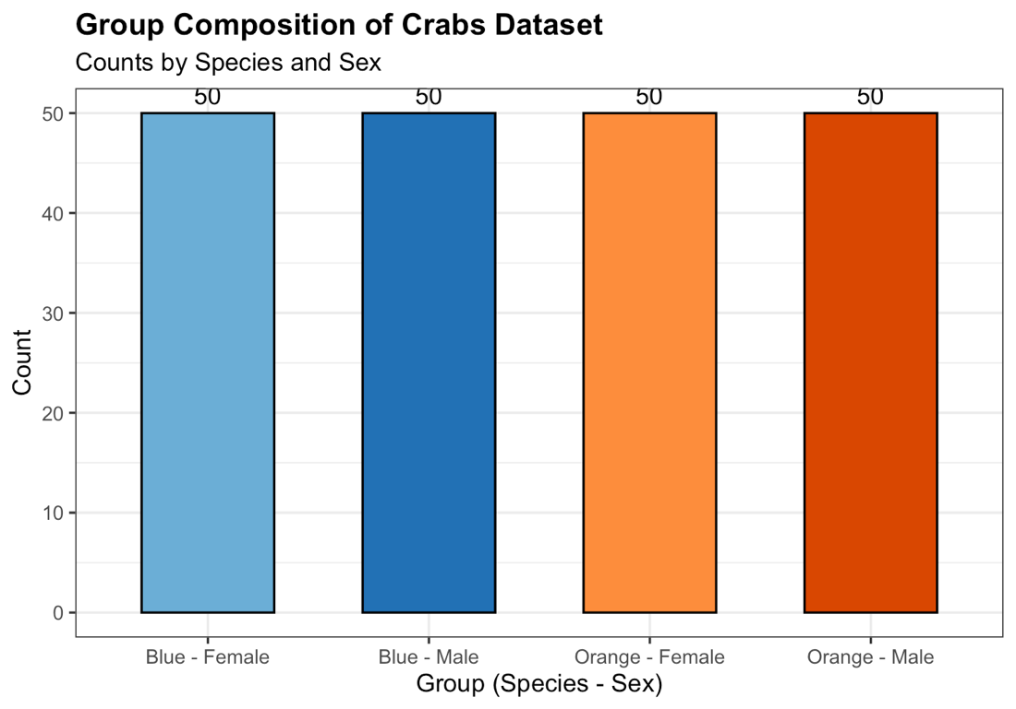
Figure 1:Group Composition by Species and Sex

- All four groups contribute equally (n = 50 each), confirming a fully balanced factorial design with respect to species and sex. This symmetry is ideal for group comparisons, as no group disproportionally influences pooled statistics.

Question 2 Distribution of Body Depth

- 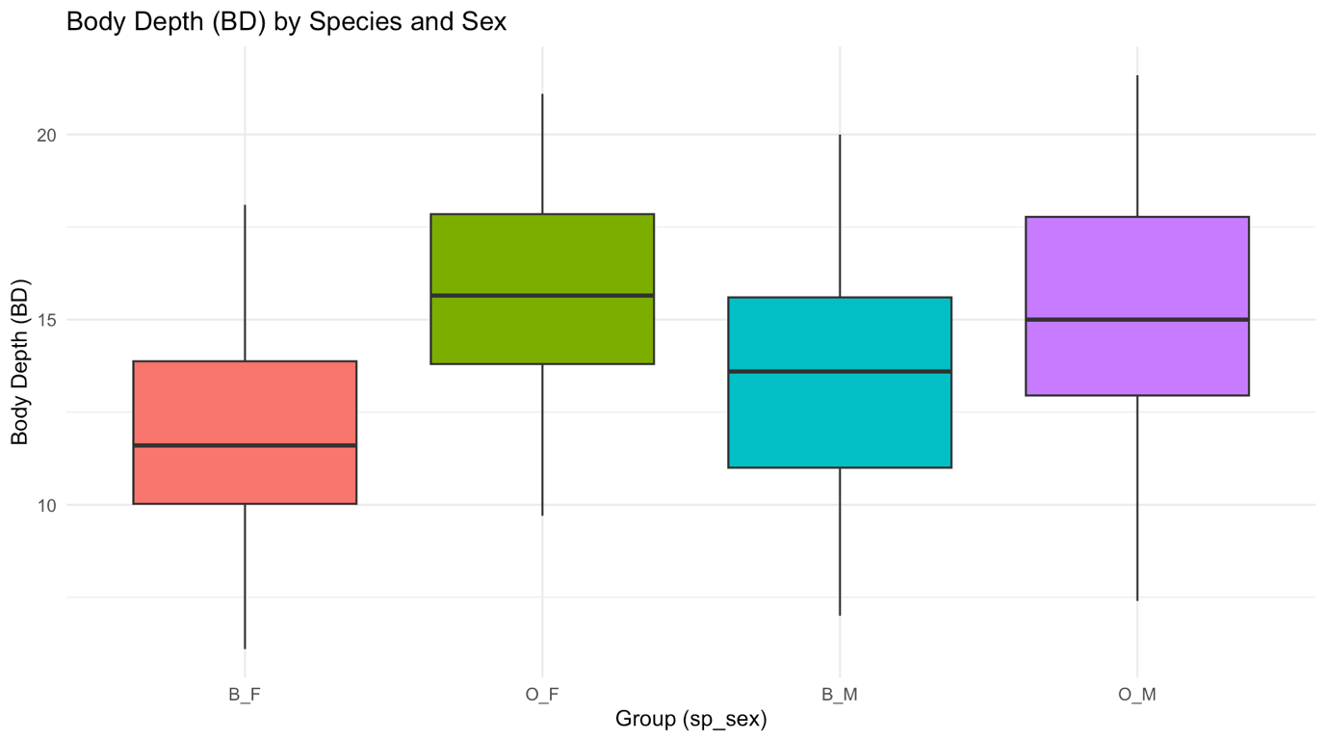
Figure 2:Body and Depth by Species and Sex

Table 4:Central Tendency and Variability Between Groups
Group | Mean | Median | SD | IQR | Min | Max
Blue Female | 11.82 | 11.60 | 2.75 | 3.85 | 6.1 | 18.1
Blue Male | 13.35 | 13.60 | 3.20 | 4.60 | 7.0 | 20.0
Orange Female | 15.63 | 15.65 | 2.75 | 4.05 | 9.7 | 21.1
Orange Male | 15.32 | 15.00 | 3.53 | 4.83 | 7.4 | 21.6

The dataset shows that Orange crabs (both female and male) have substantially greater body depth than Blue crabs. Further, Orange Female crabs exhibit the largest BD (mean 15.63 mm), followed closely by Orange Males(mean 15.32 mm).Blue crabs however, are consistently shallower in body depth. Blue Females have a mean BD of approximately 11.82 mm, and Blue Males approximately 13.35 mm.
Noteably, within each species, the sex difference in BD is relatively modest compared to the inter-species difference. Variability for Orange crabs show larger standard deviations and IQRs, indicating more heterogeneity in body depth within those groups. Blue crabs are more homogeneous in this measurement. The boxplots reveal no extreme outliers across groups, and the distributions are approximately symmetric within each group, with the median falling centrally in each box.

Question 3 Carapace Length Distribution Measurements

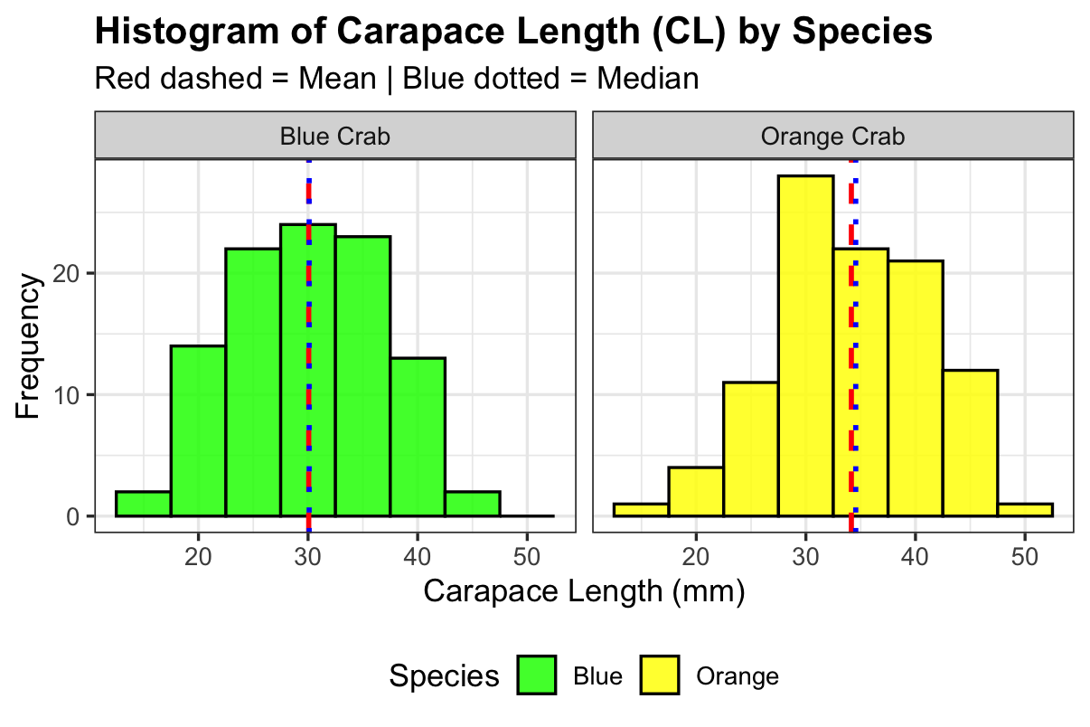
Figure 3:Histogram of Carapace Length

Table 5:Species Central Tendency
Species | Mean (mm) | Median (mm) | SD (mm) | Skewness | Excess Kurtosis
Blue (B) | 30.06 | 30.10 | 6.90 | 0.026 | -0.652
Orange (O) | 34.15 | 34.55 | 6.76 | -0.154 | -0.563

Blue crabs (B): The histogram shows an approximately unimodal, right-skewed (positivelyskewed) distribution. The mean exceeds the median, and the right tail extends further than the left,indicating a cluster of crabs with notably large carapace lengths. The positive skewness value in Table 5 confirms this visual impression.
Orange crabs (O): The distribution is also unimodal, but appears more symmetric or very slightly right-skewed. The mean and median are close together, and the histogram is more evenlyspread around the centre. The skewness value is near zero, consistent with approximate symmetry.

Both species exhibit unimodal distributions no evidence of bimodality suggesting that within each species, carapace length follows a single-peaked distribution rather than arising from a mixture of sub-populations.The greater spread (SD) in Orange crabs indicates more variation in carapace length within that species.

Question 4 Comparison of Mean Measurements

Table 6:Morphological Measurements by Species and Sex
Group | FL(mm) | RW(mm) | CL(mm) | CW(mm) | BD(MM)
Blue Female | 13.27 | 12.14 | 28.10 | 32.62 | 11.82
Blue Male | 14.84 | 11.72 | 32.01 | 36.81 | 13.35
Orange Female | 17.59 | 14.84 | 34.62 | 39.04 | 15.63
Orange Male | 16.63 | 12.26 | 33.69 | 37.19 | 15.32

- 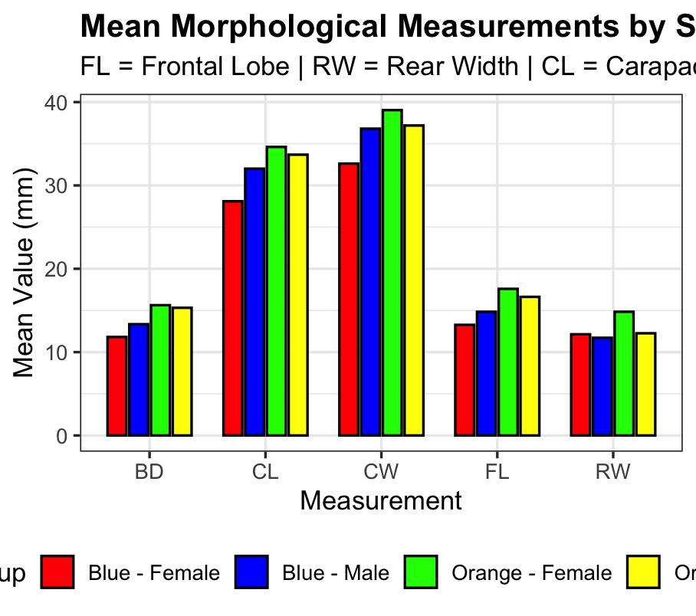

- Rear Width (RW) exhibits the greatest sex-based variation across both species, with females having proportionally wider rear widths relative to body size, reflecting its role in egg brooding and making it the most sexually dimorphic measurement. In contrast, Frontal Lobe size (FL) shows the least sex-based variation, as mean FL values for males and females within each species are very similar, indicating minimal sexual dimorphism. These results align with established biological understanding of the genus Leptograpsus, where female rear width is enlarged for reproductive purposes while cranial dimensions remain relatively conserved between sexes.

Table 7:Greatest Species Difference and the Least Sex Variation
Species | Measurement | Female Mean | Male Mean | |F - M| | % Difference
Blue | FL | 13.27 | 14.84 | 1.57 | 11.18
Blue | RW | 12.14 | 11.72 | 0.42 | 3.52
Blue | CL | 28.10 | 32.01 | 3.91 | 13.01
Blue | CW | 32.62 | 36.81 | 4.19 | 12.06
Blue | BD | 11.82 | 13.35 | 1.53 | 12.19
Orange | FL | 17.59 | 16.63 | 0.97 | 5.66
Orange | RW | 14.84 | 12.26 | 2.57 | 19.00
Orange | CL | 34.62 | 33.69 | 0.93 | 2.72
Orange | CW | 39.04 | 37.19 | 1.85 | 4.85
Orange | BD | 15.63 | 15.32 | 0.31 | 1.99

Question 5. Relationships Between Measurements

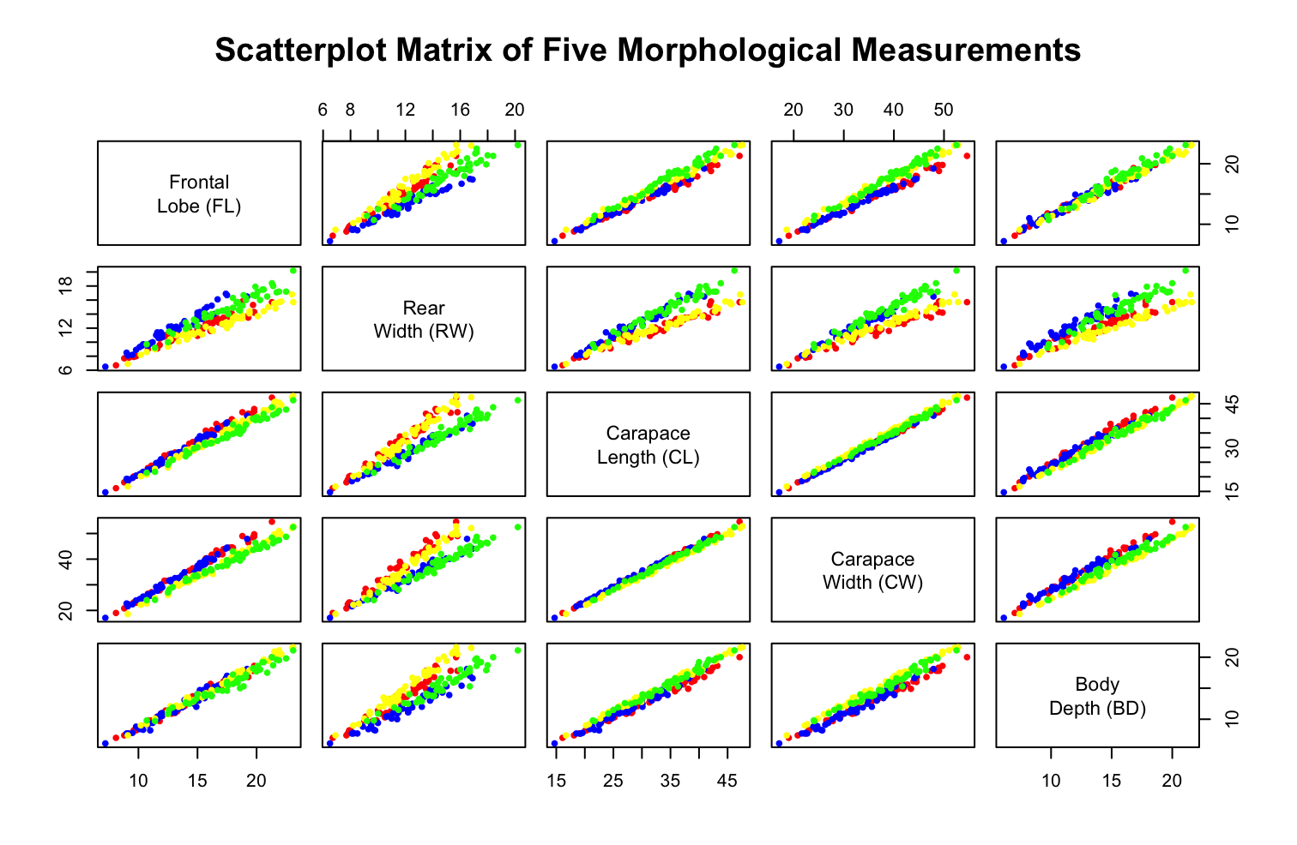
Figure 4:Scatterplot Matrix of the Five Measurements

- The pairs plot (Figure 4) and correlation matrix (Table 8) show a consistent pattern of universally strong positive relationships among all five morphological measurements. The strongest associations are observed between Carapace Length (CL) and Carapace Width (CW) (r = 0.995), as well as between Frontal Lobe (FL) and CL (r = 0.979) and between CW and Body Depth (BD) (r = 0.968), reflecting highly coordinated structural growth. Although Rear Width (RW) is also strongly correlated with the other measurements, its correlations particularly with BDare are comparatively lower, suggesting that RW exhibits slightly greater variability and relative independence within the overall growth pattern.

Table 8:Pearson Correlation Matrix of the Five Morphological Measurments
 | FL | RW | CL | CW | BD
FL | 1.000 | 0.907 | 0.979 | 0.965 | 0.988
RW | 0.907 | 1.000 | 0.893 | 0.900 | 0.889
CL | 0.979 | 0.893 | 1.000 | 0.995 | 0.983
CW | 0.965 | 0.900 | 0.995 | 1.000 | 0.968
BD | 0.988 | 0.889 | 0.983 | 0.968 | 1.000

Question 6: Integrated Statistical Report
The crabs dataset from the MASS package in R contains morphometric measurements on 200 specimens of the rock crab Leptograpsus variegatus, recorded across two species (Blue and Orange) and two sexes (Female and Male). The dataset is perfectly balanced, with exactly 50 crabs in each of the four species-sex groups, making it well-suited for comparative statistical analysis. Five continuous morphological measurements were examined: frontal lobe size (FL), rear width (RW), carapace length (CL), carapace width (CW), and body depth (BD) all recorded in millimetres. This balance ensures equal precision of estimation across groups and simplifies subsequent comparative analyses.
The descriptive analysis revealed clear and consistent differences between species and sexes. Orange crabs were systematically larger than Blue crabs across nearly all morphological dimensions, with body depth showing the most pronounced species-level difference. Within species, rear width (RW) emerged as the most sexually dimorphic measurement, with females recording proportionally larger rear widths than males a biological adaptation linked to egg-brooding, while frontal lobe size (FL) showed the least sex-based variation. The carapace length distribution of Blue crabs was right-skewed, indicating the presence of a small number of large individuals pulling the mean upward, whereas Orange crabs displayed a more symmetric and wider distribution, reflecting greater heterogeneity in body size within that species.
The multivariate analysis confirmed that all five morphological measurements are strongly and positively intercorrelated, with most pairwise Pearson correlations exceeding 0.90, consistent with proportional isometric growth across body dimensions. The strongest relationship was observed between carapace length and carapace width, reflecting the geometric constraint of shell growth, while rear width showed comparatively lower correlations with the remaining variables due to its sex-linked component. These findings collectively suggest that future analyses should consider formal hypothesis testing through two-way ANOVA, linear discriminant analysis (LDA) to assess group classification accuracy, and principal component analysis (PCA) to disentangle overall size variation from shape variation, thereby providing a deeper understanding of the morphometric structure of this species.

